LAB 2

NAME: KAUSHAL KHATIWADA

ROLL_NO: 13

1. Insert at least 5 tuples in each of the tables of the Yourname_Roll_COMPANY database in LAB-1

Inserted records in all 5 tables.

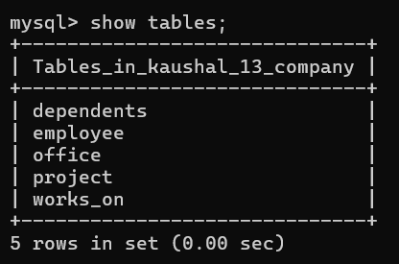

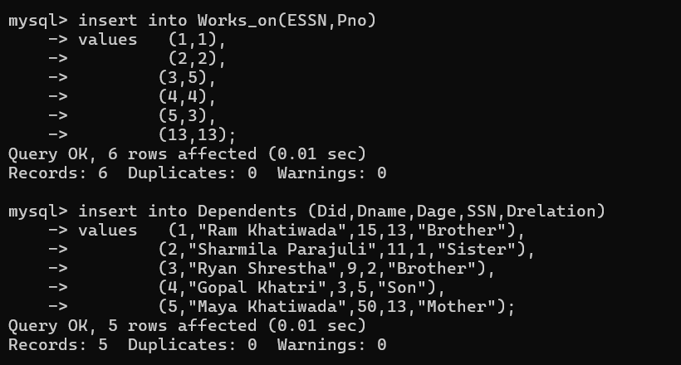

1. In the database Yourname_Roll_COMPANY in LAB-1, Create a table PF(PFID, SSN, PFCategoryName, Amount, Start_date, Remarks); where SSN is foreign key referencing Employee. The start date should be of date type.

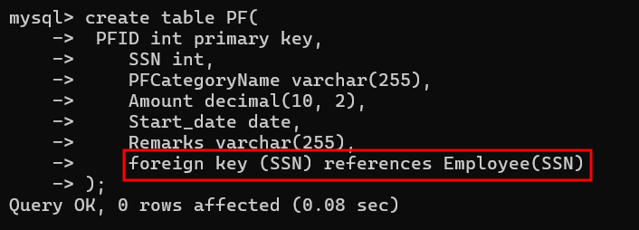

1. In the database Yourname_Roll_COMPANY in LAB-1, alter the table Employee and add an attribute Matrital_status of type varchar. Update the records in the table and set values of status to “Married”, “Single”, “Divorced”. At least three records should have status married.

*Alter table Employee*

*Add Matrial_status varchar(50);*

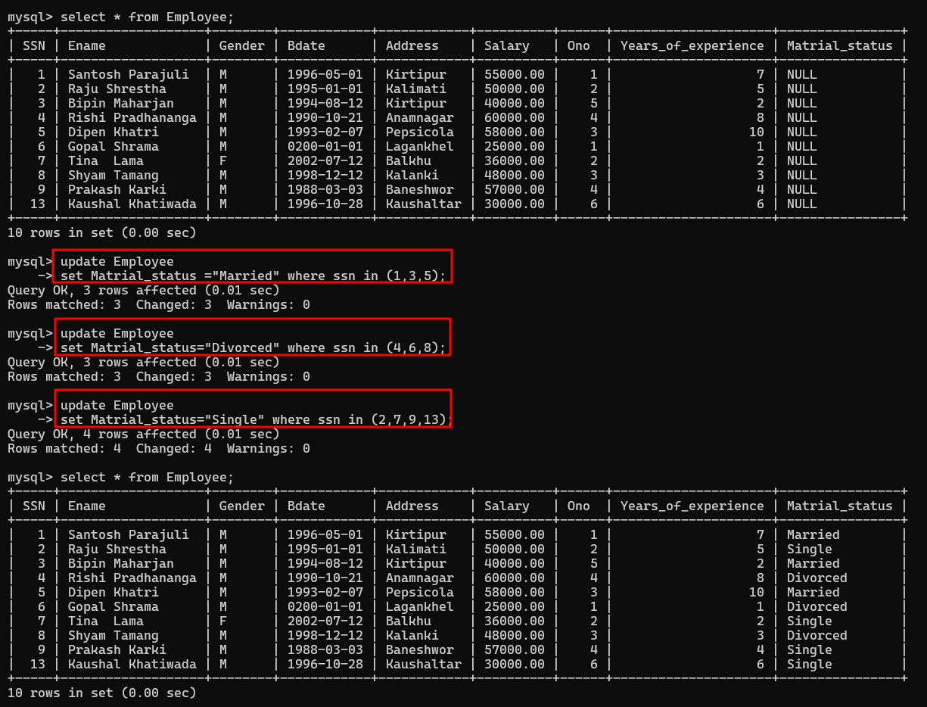

1. Insert ten records in the table PF, where at least two records have the Remarks field NULL.

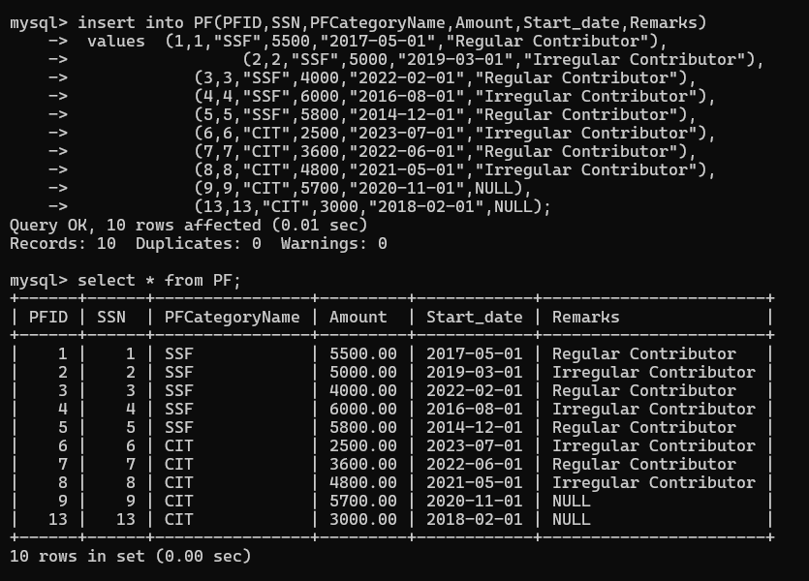

1. Select all employees.

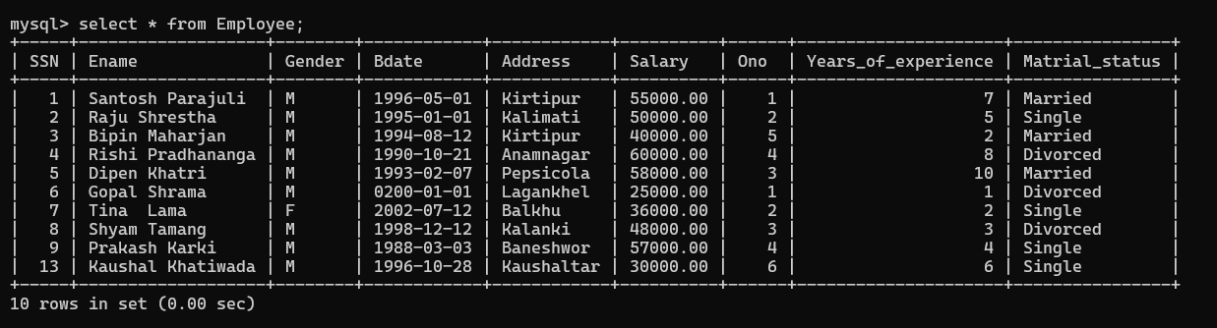

1. Select employees having salary greater than 30000 and list the results in descending order of Ename.

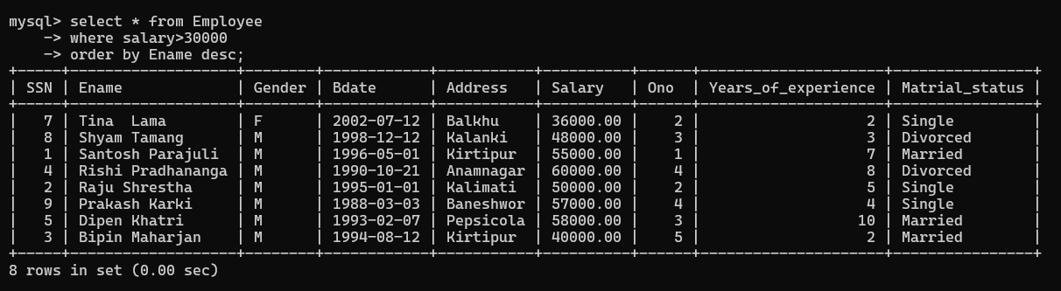

1. Retrieve the tuples from project table. Sort the tuples on the basis of Pname.

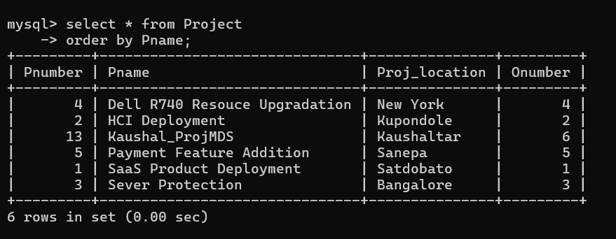

1. Select the employees having salary greater than 30000 and years of experience less than 3 years.

1. Select the name, address, and salary of employees having salary greater than 30000 or years of experience less than 3 years.

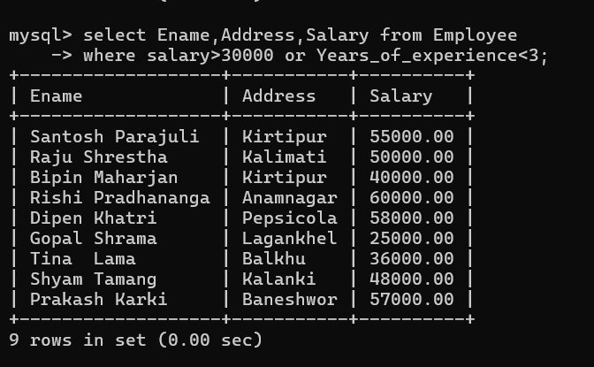

1. Select the all dependents.

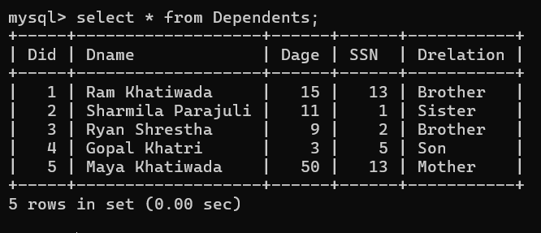

1. Select the name and age of the dependents having age between 5 to 60.

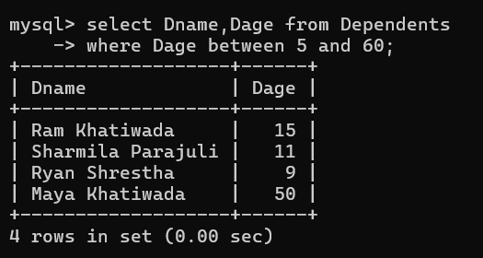

1. Select the offices having office name like “%Nt%” as substring.

1. Select the offices having office number in (1, 2, 3).

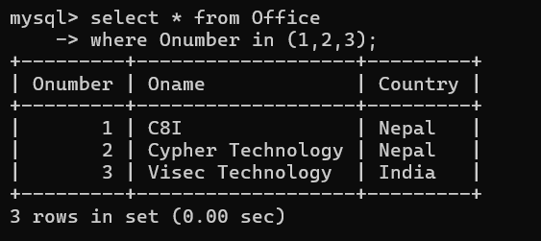

1. Select the records from PF table where remarks is NULL

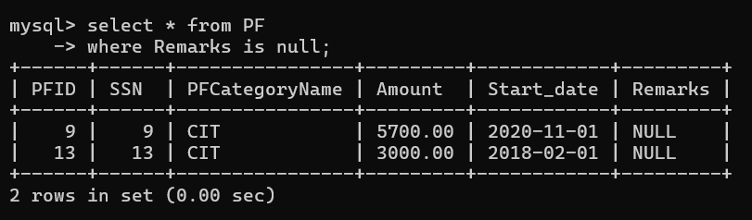

1. Select PF category name, amount, start date and remarks from PF where remarks is not NULL

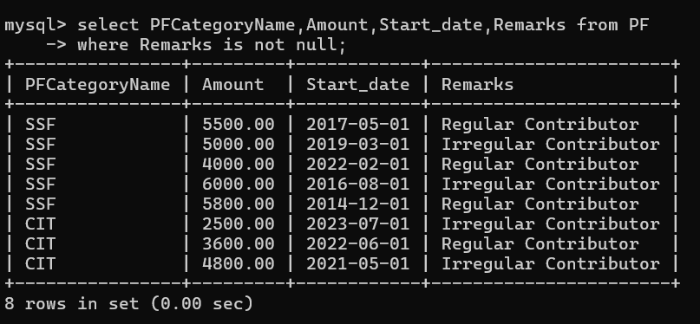

1. Select the five records from PF table using LIMIT Clause.

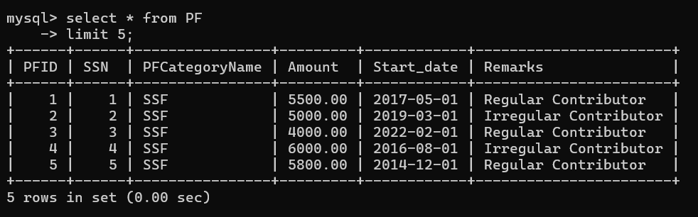

1. Select the category name of PF where amount is not equal to 3000.

1. Select all employees who works on project no 2.

